**DBMS STUDENT PROJECT REPORT**

**ACADEMIC YEAR 2023-24**

**Project Title:**

| The SQL Enigma: 1945 Japan |
| --- |

**Students:**

| **Sr. No.** | **Student Name** | **Enrolment No** | **Sem / Course** |
| --- | --- | --- | --- |
| 1 | Trisha Rami | 20220701031 | B.Sc. sem 3 |
| 2 | Niraj Sharma | 20220701012 | B.Sc. sem 3 |

**GitHub Project Link:**

| https://github.com/nevermindyou24/dbms-project |
| --- |

**Faculty: Jatin Ambasana Dean: Dr. Raju Shanmugam**

**UNITEDWORLD SCHOOL OF COMPUTATIONAL INTELLIGENCE**

**KARNAVATI UNIVERSITY**

**INDEX**

| **Sr. No.** | **Title** | **Page No.** |
| --- | --- | --- |
| 1 | Introduction  (Story / Game scenario / Simple explanation about the database) | 04 |
| 2 | Database Design | 10 |
|  | * ER Diagram 1 (Drawn on Paper using Old Notations) | 10 |
|  | * ER Diagram 2 (Drawn using Software) | 12 |
| 3 | Table Schema (Includes Table name and column names) | 13 |
| 4 | Tables with dummy data (Also share in EXCEL file separately) | 14 |
| 5 | SQL Commands  (for building and populating the database - share in a Text file separately) | 15 |
|  | * Create Table commands | 15 |
|  | * Insert commands | 16 |
| 6 | Sample queries for practicing and learning SQL  (Questions and Answers) | 22 |

**Note:** Also submit a Zip file containing all these:

* This report containing points 1 to 6.
* Excel file for point 4 (Table with dummy data).
* Text file for point 5 (SQL commands).

**The SQL enigma: 1945 Japan**

**Storyline:**

In a world where information is power, an ancient and enigmatic database has been discovered. An infamous incident of 1945, is still taken into consideration where the antagonist is living in disguise on the cobbled streets of Hokkaido, Japan.

A Japanese Sherlock takes on the role of intrepid adventurers who embark on a quest to unlock the mysteries in the journey ahead. While the antagonist is planning on attacking Japan again in an isolated destination, he drops the clue on the cobbled streets.

One of the civilians navigates its limelight on the clue, way back to his home at midnight and conveys it to the police department, which is later collected by the sherlock. Through the datasets and queries, the protagonist is able to solve the mission towards finding the culprit and his blueprints and triumph over all his evil strategies.

Armed with their SQL skills and an inquisitive mind, they embark on a thrilling quest to uncover the truth behind a mysterious crash. To do so, they must become SQL masters and navigate the complex and ever-changing database. Along the way, they encounter challenges, puzzles, and adversaries that guard the database's secrets.

**Game Scenario:**

Taken into consideration, the infamous incident held in 1945, Japan, where millions of innocent citizens died and some alive with such brutalizing allergies and diseases which can never be cured or diagnosed. No one ever knew that Hiroshima and Nagasaki would face one of the most horrifying nightmares of the entire human race. It was much more disastrous than the natural calamities.

After such a nightmare, no one could have ever imagined that Japan would grow this powerful and impactful as a country with wide tourist attractions, hotel buildups etc. maintaining a perfect balance between nature and technology. A real example of modernization and sticking to their roots. The amount of unity, evolution with time and wisdom they still share and retain among their citizens is just inexplicable.

This story is a self-image of Japan. Despite being such a powerful country they still face terrorist attacks from their rival nations out of envy and jealousy. This game takes you around the intruder’s mastermind strategies, cognizant citizens and a brilliant detective, a special operating force of the police department in Hokkaido.

There is this intruder living in disguise for several years in Japan’s one of the beautiful tourist attracting city, Hokkaido. He changes his identity for every small crimes he does. He has only revealed his real identity for once, when he was charged for smuggling unsafe drugs near Suskino, a port blair of Hokkaido. He was charged and sentenced to 12 years of jail. He was identified as an international smuggler by the police department of Hokkaido. He got released from the jail by the officers and he got missing ever since. Little did everyone knew that he was on a mission, something huge and horrendous. Smuggling was all in his plan and he was planning every structure of his goal most precisely for 12 years straight. He was an obsessed mastermind with an eagle tattoo at the back of his neck.

At a starry midnight, a chef was going back to his home, completing all his work with a satisfied smile yet an exhausted mind. He was a Michelin Star chef working in a very lavish hotel management chain of Hokkaido, Sapporo Grand. While going back to his home, he saw something which captivated his eyes. He saw something at the backgate of the hotel which was very unusual. It was a chemical substance! It was in a transparent glass bottle with a bark cap, safely packed and preserved. As a chef, he had blessed olfactory nerves and receptors to detect and discriminate odours as well as social cues which influence our innate responses. It was yellow in color, crystalline in texture, smelled odourless as he described. It was packed in a sample glass bottle. He knew something was weird, this substance was unusual. Only that, this word was dominating his exhausted mind, his thoughts: drug!

He immediately grabbed the substance with him and rushed to the police department, where he explained the whole situation innocently. He was anxious, fear was visibly running through his entire body. The officers panicked as well, it never happened before in the city, on the cobbled streets of Hokkaido. One of the senior officers, Tejanshinata Kato called one of his team members and commanded to immediately report and consult the incident and the sample drug substance to the Forensic Department. All they can do is to wait till tomorrow morning for the results from the Forensic Department. It was a long night for everyone who were present there, maybe something tremendous was coming for Hokkaido on its way, no one ever knew.

Bright Morning yet an important one, everyone was waiting for two things: the sample result and the detective, Yumi Yamaguchi from the police department. She was awarded one of the highest national badges, internationally awarded, and one of the most infamous personalities in Japan. She earned the goodwill yet still resides in her hometown. Last night, after reporting to the Forensic department, officer Tejanshinata also called and reported to Ms. Yumi about the circumstances. She was a special operating force from the Police Department. The chef, Adikoto Matsumoto was also present at the moment in the police department as he was the first victim of this case.

Ms. Yumi reported to the police cell after a while, as did the forensic reports. Due to an alarming situation, the procedure took place in the forensics lab yesterday. Scientists were working their brain off all night for 10 hours straight, just to obtain a terrifying report. Henceforth, the forensic department concluded that it was an unsafe chemical substance which was smuggled to Hokkaido because this drug is to be nowhere found in the country throughout. Even the scientists and researchers have to take special permissions from the government to operate such a harmful substance, radially. Due to multiple experiments conducted yesterday in the forensic labs, it was confirmed that this unusual drug is highly combustible and inflammable and can only be used in making TNT bombs. This is one of the most important and complex solidified chemicals, as an ingredient used in making TNT bombs.

Everyone was in utter shock after reading the forensic report. The detective was in deep thinking and finally took some stringent steps towards solving this case. She started with the investigation. The chef, as a victim, gave his final statement. For the investigation, the detective commanded the police officers to present the criminal records of the city and especially check the background of those criminals who were imprisoned for supplying unsafe drugs and narcotics and also who recently got released from the jail. The detective herself decided to go to the backgate of the hotel where the chef found the substance. She was accompanied by the senior police officer, Tejanshinata. Before the intruder gets alert and plans to leave the city, they need to find him/her as soon as possible.

The detective and the officer, both were discussing the intruder residing in the city. Till now whatever they go to know from the statement of the chef and the forensic reports, the concluded that:

1. Last night, he/she was near the hotel
2. He or she may have resided in the hotel because there was no other place to stay near the hotel, as it was an abandoned area.
3. He/she must have smuggled because this chemical is nowhere to be found in the country.
4. He/she doesn’t possess a Japanese nationality.
5. The intruder seems professional for dealing with such a chemical. He/she must be a drug pharmacist for a chemist.
6. The intruder must have analysed the roads of the city and lived in the city for several years and planning for this day ever since.

The clues were getting stronger, because something was linked to the hotel. The hotel was one of the most luxurious places to stay in the entire country. It also attracts a lot of tourists both nationally and internationally, even though it resided in such an abandoned area, far from the city. After noting such facts about the intruder, the detective immediately commanded the officer to give a call to the police cell and inform them to immediately send the analysed criminal record and even send the record of the citizens whose occupation is of a chemist or a drug pharmacist residing in the city, city directory. The detective was deliberately planning to compare the records and the directories to one another to catch the intruder quickly.

After a few minutes, they reached the location and were visualizing the whole scenario last night. They were contemplating the intruder’s point of view every now and then. Clean chit! No mistake from the intruder’s side to leave any evidence behind. They thought to ask the localities before asking the hotel staff. No information was obtained from the localities, no one saw a person last night at the back of the hotel. They went inside the hotel to talk to the executive manager about last night, secretly, so that the intruder doesn’t get alert and aware of the situation. The executive manager and other hotel staff members gave their statement too and unfortunately no one saw the intruder last night anywhere. The case was getting even more complex than they thought.

Additionally, there was negligible amount of time to solve the case and catch the intruder because he/she will get to know it real soon from now and plan to leave the city. The officer called the all branch cells of the city and alerted everyone about the case and ordered them to seal the borders with strict checking and barricades. Not a single person should leave the city except those who have special permissions. While the officer was busy calling the other branches, the detective gave a thought for an informal investigation. She talked to the manager to instantly take her to the security room and check all the surveillance footage. Unfortunately, the surveillance of the backgate got corrupted. That was suspicious, which confirmed that the intruder was in this hotel who himself/herself disguised as a guest.

The detective commanded the officer to spare a look at the surveillance footage of the guests, till then she checked the hotel directory. The detective got a notification in her phone, the analysed criminal records and city directory, something she was waiting for so long. She immediately checked the report. She found that there were three chemists namely: Aoi Suzuki, Abhyuren Sasaki and Nirajimoto Takahahi, from the city directory and in that she found Nirajimoto and Abhyuren were charged. To that she checked the recent dates of their release. Abhyuren recently got released and Nirajimoto was charged twice. She knew one of them had a fake Japanese identity. The intruder is one of them but still no strong evidence to prove her correct.

Keeping their released dates in mind, she checked the hotel directory of the guests who checked in after 18th November, because on this day Abhyuren got recently released from the jail. To which her surprise, she actually found two guests namely: Haruki Yamamoto and Aiko Suzuki. One of them checked in on 19th and other one on 20th, both the guests were suspicious. Her eyes goes to the identification mark column in the criminal records which she keeps that in mind too while checking the cctv footage of the guests who checked in after 18th November. The detective and the officer were watching the footages of those two guests. The guest from the 20th  was a pure Japanese breed with a smiling face. The other guest from 19th wore a mask, and while after completing the formalities, the guest turned around which made the detective stop the video immediately, just to find that the guest had an eagle tattoo on the back of his neck and as in the law stated, no one in Japan is allowed to keep a tattoo. This concludes that this guest was not from Japan, came as a tourist. Suddenly, something clicked on her mind, the date of birth column of the criminal records and the hotel records. The birthday of Hakuri Yamamoto was the same as Abhyuren Sasaki.

This was the moment both of them knew, they found the intruder with strong evidence which proved their theory of coincidence!

**Dataset Explanation:**

**Sheet 1: City Directory**

This dataset represents the total number of citizens residing in the city, Hokkaido with all necessary details like: gender, occupation, phone number, address, date of birth, age etc. This directory is mandatory for every city to record it and preserve it.

**Sheet 2: ForensicReport**

This dataset represents the storage and records of different types of chemicals with their license number, description and classification.

**Sheet 3: CriminalRecords**

This dataset represents the total number of criminals in the city, who were arrested for the type of offense they conducted to harm their surroundings or the city in any way. With important and secretive information about them, this data is only accessible to the police department.

**Sheet 4: PolicePersonnel**

This dataset represents the total number of police officers residing in the city, Hokkaido. With their personal information, their badge number and the achievements they’ve conquered till now.

**Sheet 5: HotelBookings**

This dataset represents the lists of the guests who have resided in the hotel, with their personal information, their stay duration and most importantly the guest id. These records are automatically updated and preserved for years.

**Database Design:**

1. **ER Diagram 1**

**-**A visual representation of the relationships and exchanges between various entities in a system is called an entity-relationship (ER) diagram. We can draw an ER diagram to show the protagonist of the game and their connections in a criminal and detective scenario. This is a quick overview of the ER diagram:

**Entities:**

1. **Police Personnel:**

Attributes: officerid(primary key), officer_names,contacts, badge_number, division,gender, officer_classification.

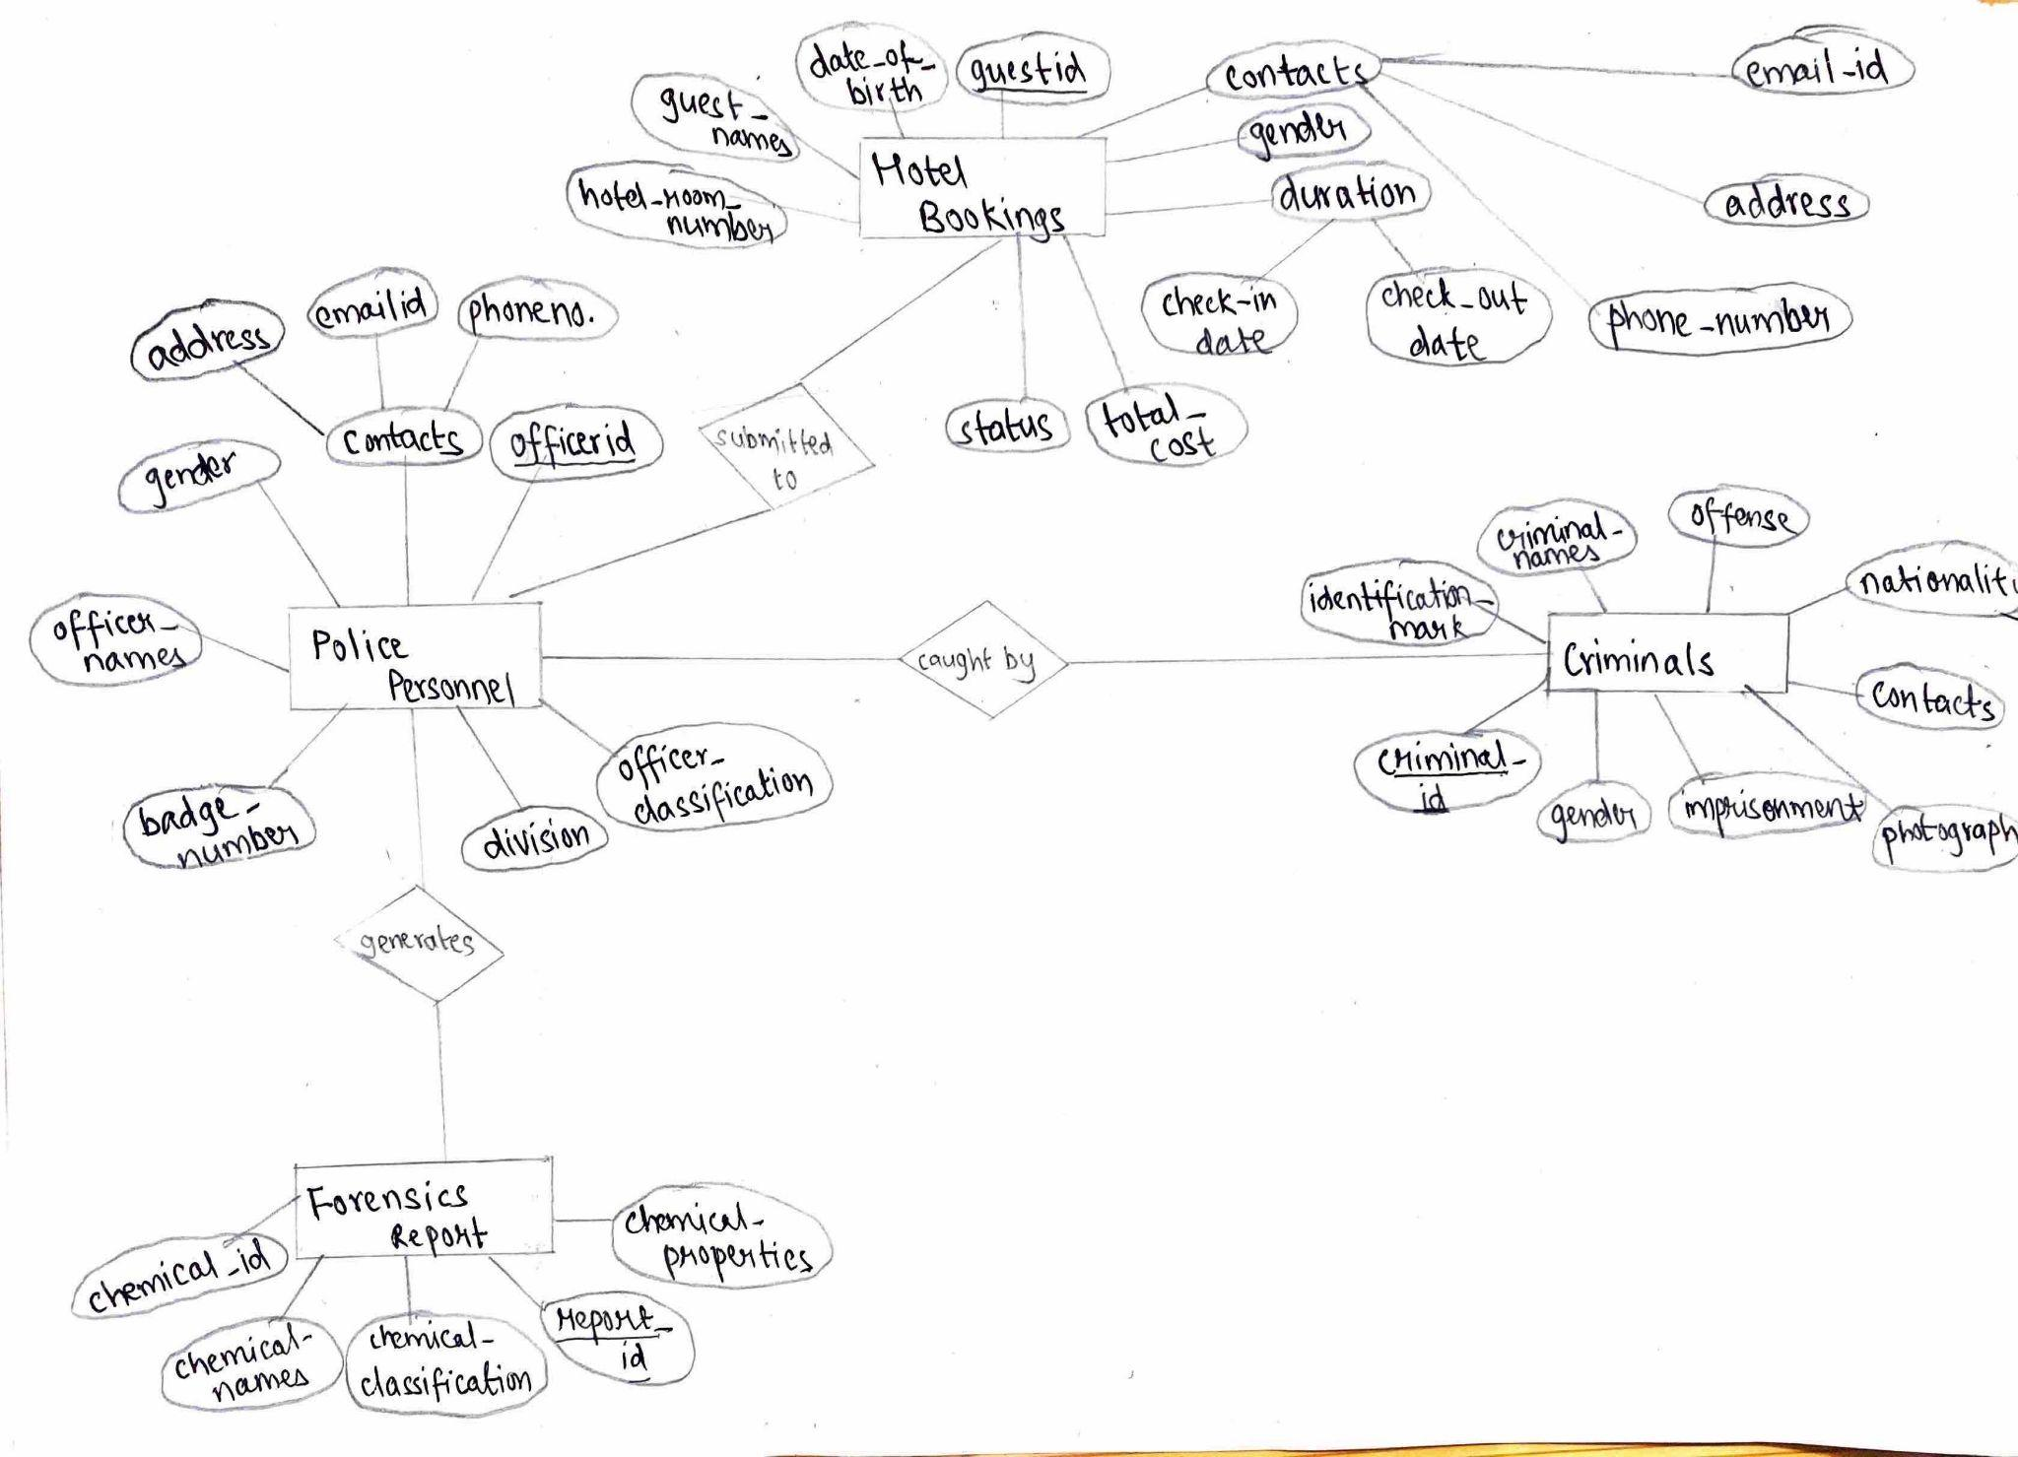

1. **Hotel Bookings:**

Attributes: guestid(primary key), guest_names, hotel_room_number,duration,contacts,gender, date_of_birth.

1. **Criminals:**

Attributes: criminalid(primary key), imprisonment, photographs, gender, contacts, nationality, identifiation_mark, offense.

1. Forensics Report:

Attributes: reportid(primary key), chemical_id, chemical_names, chemical_classification, chemical_properties.

**Relationships:**

1. **submitted to**:

a relationship between Police Personnel and Hotel Bookings, where the hotel guest information is submitted to the police.

1. **caught by:**

a relationship between Police Personnel and Criminals, where the criminals have been caught by the police and criminal records are maintained.

1. **generates:**

a relationship between Police Personnel and Forensics Report, where the result report is generated by the forensics and passed onto the police further.

**(2) ER Diagram 2**

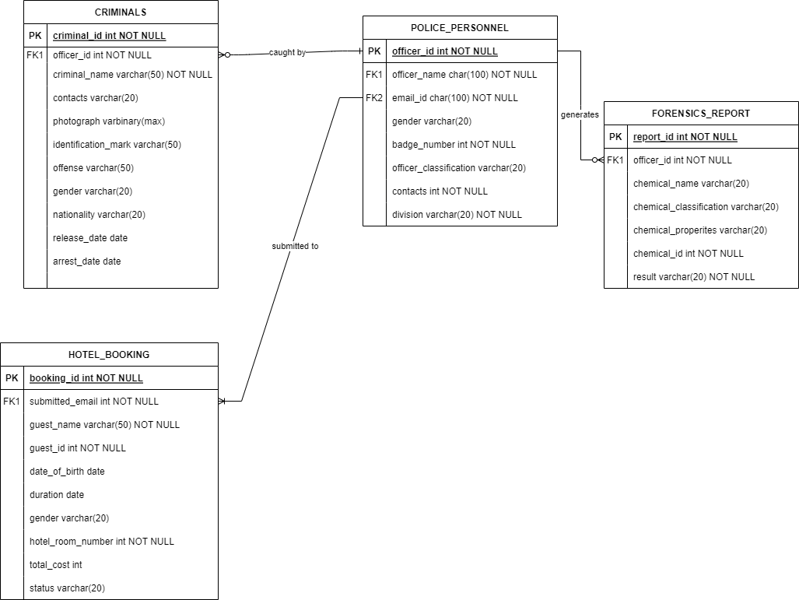

1. **Criminals:**

Foreign Key: officer_id

Cardinality: zero-to-one(0:1)

Relationship: caught by

Joined to: Police Personnel

1. **Hotel_Bookings:**

Foreign Key: submitted_email

Cardinality: one-to-many(1:M)

Relationship: submitted to

Joined to: Police Personnel

1. **Police Personnel:**

Foreign Key: officer_name, email_id

Cardinality: zero-to-many(0:M)

Relationship: generates

Joined to: Forensics Report

1. **Forensics Report**

Foreign Key: officer_id

Cardinality: many-to-zero(M:0)

Relationship: generates

Joined to: Police Personnel

**Table Schema:**

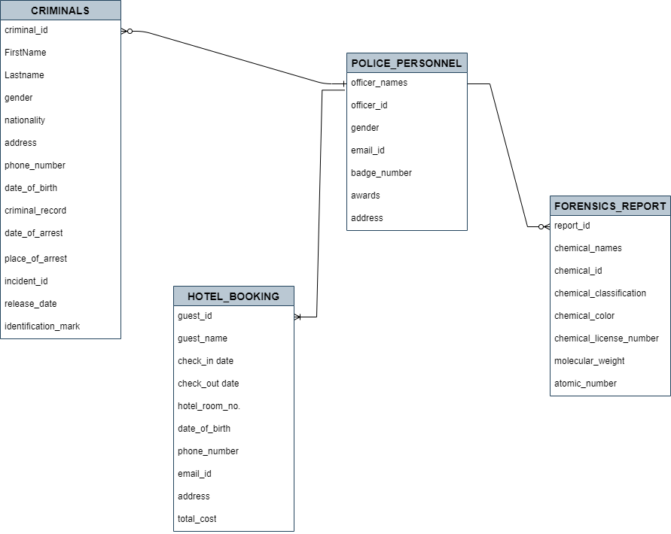

**Tables with Dummy Dataset:**

**1)**

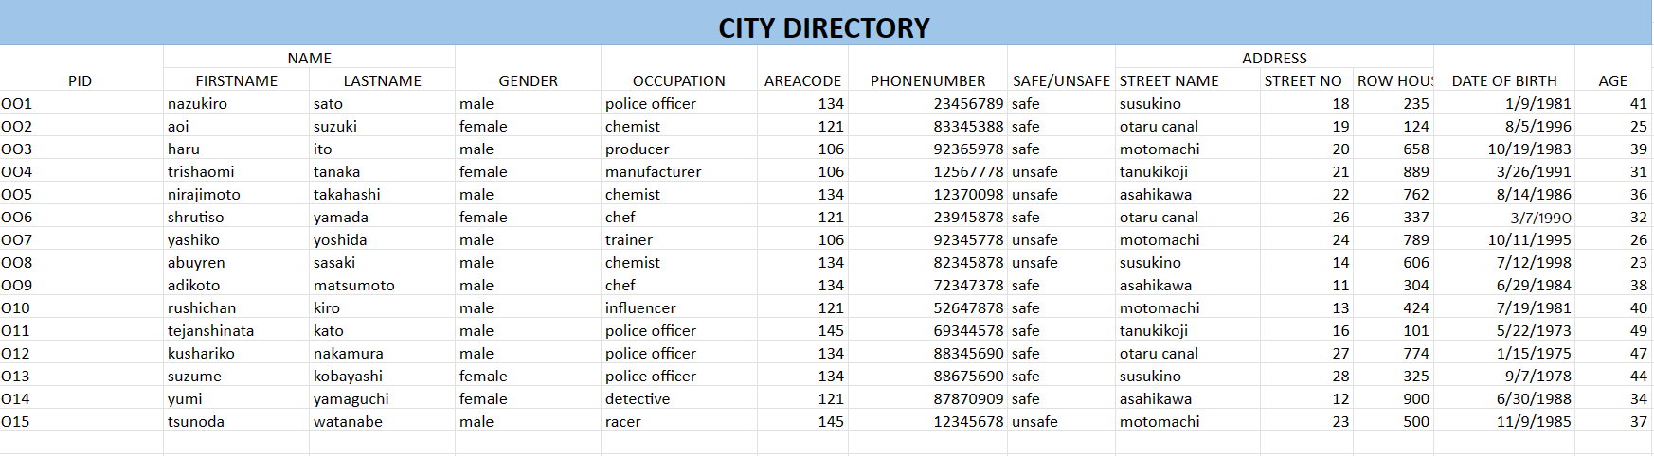

**2)**

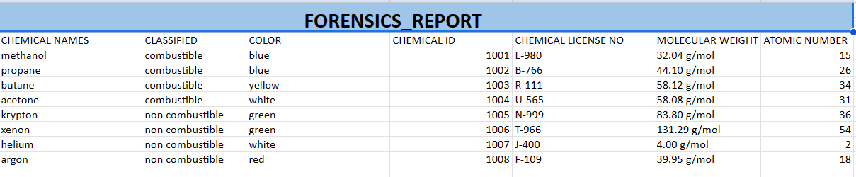

**3)**

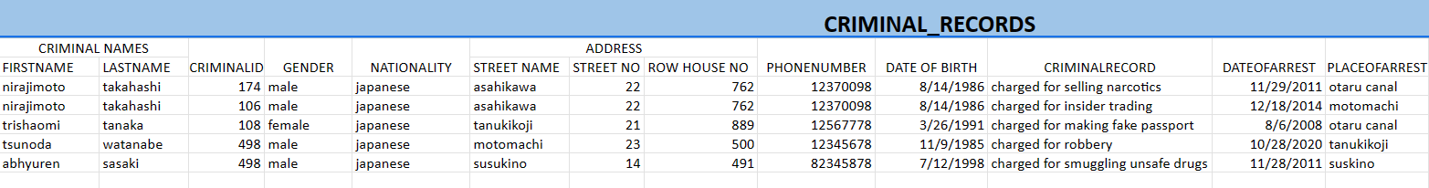

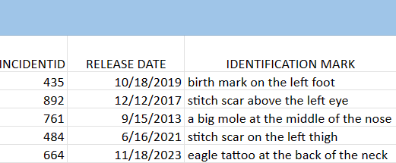

**4)**

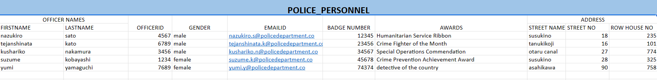

**5)**

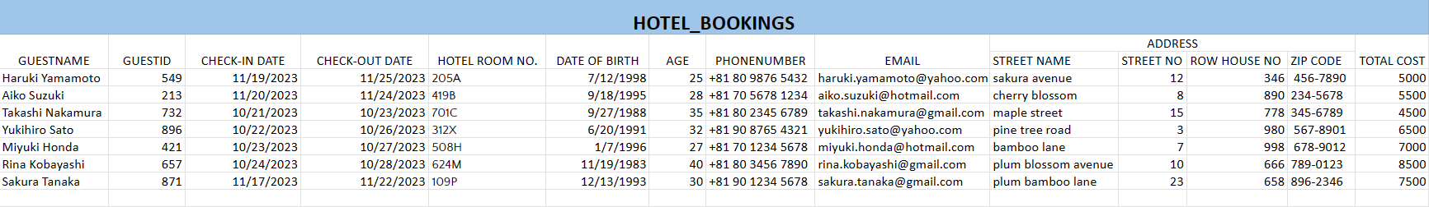

**SQL Commands:**

1. **Create Table Commands**

**City Directory:**

**CREATE TABLE city_directory (**

**pid NUMBER PRIMARY KEY,**

**name VARCHAR2(50),**

**gender VARCHAR2(10),**

**occupation VARCHAR2(50),**

**area_code NUMBER,**

**phone_number NUMBER,**

**safety_status VARCHAR2(10),**

**address VARCHAR2(100),**

**date_of_birth DATE,**

**age NUMBER**

**);**

**Forensic Report:**

**CREATE TABLE forensic_report (**

**chemical_name VARCHAR2(50),**

**classified VARCHAR2(50),**

**color VARCHAR2(50),**

**chemical_id NUMBER PRIMARY KEY,**

**chemical_license_no VARCHAR2(50),**

**molecular_weight VARCHAR2(20),**

**atomic_number NUMBER**

**);**

**Criminal Records:**

**CREATE TABLE criminal_records (**

**CriminalID INT,**

**FirstName VARCHAR(255),**

**LastName VARCHAR(255),**

**Gender VARCHAR(10),**

**StreetName VARCHAR(255),**

**StreetNo INT,**

**RowHouseNo INT,**

**PhoneNumber VARCHAR(20),**

**DateOfBirth DATE,**

**CriminalRecord VARCHAR(255),**

**DateOfArrest DATE,**

**PlaceOfArrest VARCHAR(255),**

**IncidentID INT,**

**ReleaseDate DATE,**

**IdentificationMark VARCHAR(255)**

**);**

**Police Personnel:**

**CREATE TABLE police_personnel (**

**officer_id NUMBER PRIMARY KEY,**

**first_name VARCHAR2(50),**

**last_name VARCHAR2(50),**

**gender VARCHAR2(10),**

**email_id VARCHAR2(100),**

**badge_number NUMBER,**

**awards VARCHAR2(50),**

**address VARCHAR2(150)**

**);**

**Hotel Bookings:**

**CREATE TABLE Hotel_bookings (**

**GuestID INT,**

**GuestName VARCHAR(255),**

**CheckinDate DATE,**

**CheckoutDate DATE,**

**HotelRoomNo VARCHAR(10),**

**DateOfBirth DATE,**

**Age INT,**

**PhoneNumber VARCHAR(20),**

**Email VARCHAR(255),**

**Address VARCHAR(255),**

**TotalCost INT**

**);**

1. **Insert Commands**

**City Directory:**

**-- Person with pid 1**

**INSERT INTO city_directory (pid, name, gender, occupation, area_code, phone_number, safety_status, address, date_of_birth, age)**

**VALUES (1, 'nazukiro sato', 'male', 'police officer', 134, 23456789, 'safe', 'susukino St.18 - House No 235',DATE '1981-01-09', 41);**

**-- Person with pid 2**

**INSERT INTO city_directory (pid, name, gender, occupation, area_code, phone_number, safety_status, address, date_of_birth, age)**

**VALUES (2, 'aoi suzuki', 'female', 'chemist', 121, 83345388, 'safe', 'otaru canal St.19 - House No 124', DATE '1996-08-05', 25);**

**-- Person with pid 3**

**INSERT INTO city_directory (pid, name, gender, occupation, area_code, phone_number, safety_status, address, date_of_birth, age)**

**VALUES (3, 'haru ito', 'male', 'producer', 106, 92365978, 'safe', 'motomachi St.20 - House No 658', DATE '1983-10-19', 39);**

**-- Person with pid 4**

**INSERT INTO city_directory (pid, name, gender, occupation, area_code, phone_number, safety_status, address, date_of_birth, age)**

**VALUES (4, 'trishaomi tanaka', 'female', 'manufacturer', 106, 12567778, 'unsafe', 'tanukikoji St.21 - House No 889', DATE '1991-03-26', 31);**

**-- Person with pid 5**

**INSERT INTO city_directory (pid, name, gender, occupation, area_code, phone_number, safety_status, address, date_of_birth, age)**

**VALUES (5, 'nirajimoto takahashi', 'male', 'chemist', 134, 12370098, 'unsafe', 'asahikawa St.22 - House No 762', DATE '1986-08-14', 36);**

**-- Person with pid 6**

**INSERT INTO city_directory (pid, name, gender, occupation, area_code, phone_number, safety_status, address, date_of_birth, age)**

**VALUES (6, 'shrutiso yamada', 'female', 'chef', 121, 23945878, 'safe', 'otaru canal St.26 - House No 337', DATE '1990-03-07', 32);**

**-- Person with pid 7**

**INSERT INTO city_directory (pid, name, gender, occupation, area_code, phone_number, safety_status, address, date_of_birth, age)**

**VALUES (7, 'yashiko yoshida', 'male', 'trainer', 106, 92345778, 'unsafe', 'motomachi St.24 - House No 789', DATE '1995-10-11', 26);**

**-- Person with pid 8**

**INSERT INTO city_directory (pid, name, gender, occupation, area_code, phone_number, safety_status, address, date_of_birth, age)**

**VALUES (8, 'abuyren sasaki', 'male', 'chemist', 134, 82345878, 'unsafe', 'susukino St.14 - House No 606', DATE '1998-07-12', 23);**

**-- Person with pid 9**

**INSERT INTO city_directory (pid, name, gender, occupation, area_code, phone_number, safety_status, address, date_of_birth, age)**

**VALUES (9, 'adikoto matsumoto', 'male', 'chef', 134, 72347378, 'safe', 'asahikawa St.11 - House No 304', DATE '1984-06-29', 38);**

**-- Person with pid 10**

**INSERT INTO city_directory (pid, name, gender, occupation, area_code, phone_number, safety_status, address, date_of_birth, age)**

**VALUES (10, 'rushichan kiro', 'male', 'influencer', 121, 52647878, 'safe', 'motomachi St.13 - House No 424', DATE '1981-07-19', 40);**

**-- Person with pid 11**

**INSERT INTO city_directory (pid, name, gender, occupation, area_code, phone_number, safety_status, address, date_of_birth, age)**

**VALUES (11, 'tejanshinata kato', 'male', 'police officer', 145, 69344578, 'safe', 'tanukikoji St.16 - House No 101', DATE '1973-05-22', 49);**

**-- Person with pid 12**

**INSERT INTO city_directory (pid, name, gender, occupation, area_code, phone_number, safety_status, address, date_of_birth, age)**

**VALUES (12, 'kushariko nakamura', 'male', 'police officer', 134, 88345690, 'safe', 'otaru canal St.27 - House No 774', DATE '1975-01-15', 47);**

**-- Person with pid 13**

**INSERT INTO city_directory (pid, name, gender, occupation, area_code, phone_number, safety_status, address, date_of_birth, age)**

**VALUES (13, 'yumi kobayashi', 'female', 'police officer', 134, 88675690, 'safe', 'susukino St.28 - House No 325', DATE '1978-09-07', 44);**

**-- Person with pid 14**

**INSERT INTO city_directory (pid, name, gender, occupation, area_code, phone_number, safety_status, address, date_of_birth, age)**

**VALUES (14, 'yumi yamaguchi', 'female', 'detective', 121, 87870909, 'safe', 'asahikawa St.12 - House No 900', DATE '1988-06-30', 34);**

**-- Person with pid 15**

**INSERT INTO city_directory (pid, name, gender, occupation, area_code, phone_number, safety_status, address, date_of_birth, age)**

**VALUES (15, 'tsunoda watanabe', 'male', 'racer', 145, 12345678, 'unsafe', 'motomachi St.23 - House No 500', DATE '1985-11-09', 37);**

**select * from City_Directory**

**Forensics Report:**

**-- Insert data into the forensic_report table**

**INSERT INTO forensic_report (chemical_name, classified, color, chemical_id, chemical_license_no, molecular_weight, atomic_number)**

**VALUES ('methanol', 'combustible', 'blue', 1001, 'E-980', '32.04 g/mol', 15);**

**INSERT INTO forensic_report (chemical_name, classified, color, chemical_id, chemical_license_no, molecular_weight, atomic_number)**

**VALUES ('propane', 'combustible', 'blue', 1002, 'B-766', '44.10 g/mol', 26);**

**INSERT INTO forensic_report (chemical_name, classified, color, chemical_id, chemical_license_no, molecular_weight, atomic_number)**

**VALUES ('butane', 'combustible', 'yellow', 1003, 'R-111', '58.12 g/mol', 34);**

**INSERT INTO forensic_report (chemical_name, classified, color, chemical_id, chemical_license_no, molecular_weight, atomic_number)**

**VALUES ('acetone', 'combustible', 'white', 1004, 'U-565', '58.08 g/mol', 31);**

**INSERT INTO forensic_report (chemical_name, classified, color, chemical_id, chemical_license_no, molecular_weight, atomic_number)**

**VALUES ('krypton', 'non combustible', 'green', 1005, 'N-999', '83.80 g/mol', 36);**

**INSERT INTO forensic_report (chemical_name, classified, color, chemical_id, chemical_license_no, molecular_weight, atomic_number)**

**VALUES ('xenon', 'non combustible', 'green', 1006, 'T-966', '131.29 g/mol', 54);**

**INSERT INTO forensic_report (chemical_name, classified, color, chemical_id, chemical_license_no, molecular_weight, atomic_number)**

**VALUES ('helium', 'non combustible', 'white', 1007, 'J-400', '4.00 g/mol', 2);**

**INSERT INTO forensic_report (chemical_name, classified, color, chemical_id, chemical_license_no, molecular_weight, atomic_number)**

**VALUES ('argon', 'non combustible', 'red', 1008, 'F-109', '39.95 g/mol', 18);**

**select * from forensic_report**

**Criminal Records:**

**-- Criminal 1**

**INSERT INTO criminal_records (CriminalID, FirstName, LastName, Gender, StreetName, StreetNo, RowHouseNo, PhoneNumber, DateOfBirth, CriminalRecord, DateOfArrest, PlaceOfArrest, IncidentID, ReleaseDate, IdentificationMark)**

**VALUES (174, 'Nirajimoto', 'Takahashi', 'male', 'Asahikawa', 22, 762, '12370098', DATE '1986-08-14', 'Charged for selling narcotics', DATE '2011-11-29', 'Otaru Canal', 435, DATE '2019-10-18', 'Birthmark on the left foot');**

**-- Criminal 2**

**INSERT INTO criminal_records (CriminalID, FirstName, LastName, Gender, StreetName, StreetNo, RowHouseNo, PhoneNumber, DateOfBirth, CriminalRecord, DateOfArrest, PlaceOfArrest, IncidentID, ReleaseDate, IdentificationMark)**

**VALUES (106, 'Nirajimoto', 'Takahashi', 'male', 'Asahikawa', 22, 762, '12370098', DATE '1986-08-14', 'Charged for insider trading', DATE '2014-12-18', 'Motomachi', 892, DATE '2017-12-12', 'Stitch scar above the left eye');**

**-- Criminal 3**

**INSERT INTO criminal_records (CriminalID, FirstName, LastName, Gender, StreetName, StreetNo, RowHouseNo, PhoneNumber, DateOfBirth, CriminalRecord, DateOfArrest, PlaceOfArrest, IncidentID, ReleaseDate, IdentificationMark)**

**VALUES (108, 'Trishaomi', 'Tanaka', 'female', 'Tanukikoji', 21, 889, '12567778', DATE '1991-03-26', 'Charged for making fake passport', DATE '2008-08-06', 'Otaru Canal', 761, DATE '2013-09-15', 'A big mole at the middle of the nose');**

**-- Criminal 4**

**INSERT INTO criminal_records (CriminalID, FirstName, LastName, Gender, StreetName, StreetNo, RowHouseNo, PhoneNumber, DateOfBirth, CriminalRecord, DateOfArrest, PlaceOfArrest, IncidentID, ReleaseDate, IdentificationMark)**

**VALUES (498, 'Tsunoda', 'Watanabe', 'male', 'Motomachi', 23, 500, '12345678', DATE '1985-11-09', 'Charged for robbery', DATE '2020-10-28', 'Tanukikoji', 484, DATE '2021-06-16', 'Stitch scar on the left thigh');**

**-- Criminal 5**

**INSERT INTO criminal_records (CriminalID, FirstName, LastName, Gender, StreetName, StreetNo, RowHouseNo, PhoneNumber, DateOfBirth, CriminalRecord, DateOfArrest, PlaceOfArrest, IncidentID, ReleaseDate, IdentificationMark)**

**VALUES (498, 'Abhyuren', 'Sasaki', 'male', 'Susukino', 14, 491, '82345878', DATE '1998-07-12', 'Charged for smuggling unsafe drugs', DATE '2011-11-28', 'Suskino', 664, DATE '2023-11-18', 'Eagle tattoo at the back of the neck');**

**select * from criminal_records**

**Police Personnel:**

**-- Insert data into the police_personnel table**

**INSERT INTO police_personnel (officer_id, first_name, last_name, gender, email_id, badge_number, awards, address)**

**VALUES (4567, 'Nazukiro', 'Sato', 'male', 'nazukiro.s@policedepartment.co', 12345, 'Humanitarian Service Ribbon', 'Susukino St.18 - House No 235');**

**INSERT INTO police_personnel (officer_id, first_name, last_name, gender, email_id, badge_number, awards, address)**

**VALUES (6789, 'Tejanshinata', 'Kato', 'male', 'tejanshinata.k@policedepartment.co', 23456, 'Crime Fighter of the Month', 'Tanukikoji St.16 - House No 101');**

**INSERT INTO police_personnel (officer_id, first_name, last_name, gender, email_id, badge_number, awards, address)**

**VALUES (3456, 'Kushariko', 'Nakamura', 'male', 'kushariko.n@policedepartment.co', 34567, 'Special Operations Commendation', 'Otaru Canal St.27 - House No 774');**

**INSERT INTO police_personnel (officer_id, first_name, last_name, gender, email_id, badge_number, awards, address)**

**VALUES (1234, 'Suzume', 'Kobayashi', 'female', 'suzume.k@policedepartment.co', 45678, 'Crime Prevention Achievement Award', 'Susukino St.28 - House No 325');**

**INSERT INTO police_personnel (officer_id, first_name, last_name, gender, email_id, badge_number, awards, address)**

**VALUES (7689, 'Yumi', 'Yamaguchi', 'female', 'yumi.y@policedepartment.co', 74374, 'Detective of the Country', 'Asahikawa St.90 - House No 758');**

**select * from police_personnel**

**Hotel Bookings:**

**-- Haruki Yamamoto**

**INSERT INTO Hotel_bookings (GuestID, GuestName, CheckinDate, CheckoutDate, HotelRoomNo, DateOfBirth, Age, PhoneNumber, Email, Address, TotalCost)**

**VALUES (549, 'Haruki Yamamoto', DATE '2023-11-18', DATE '2023-11-25', '205A', DATE '1998-07-12', 25, '+81 80 9876 5432', 'haruki.yamamoto@yahoo.com', 'st. - Sakura Avenue st. no. - 12 Rowhouse no. - 346 zipcode - 456-7890', 5000);**

**-- Aiko Suzuki**

**INSERT INTO Hotel_bookings (GuestID, GuestName, CheckinDate, CheckoutDate, HotelRoomNo, DateOfBirth, Age, PhoneNumber, Email, Address, TotalCost)**

**VALUES (213, 'Aiko Suzuki', DATE '2023-11-20', DATE '2023-11-24', '419B', DATE '1995-09-18', 28, '+81 70 5678 1234', 'aiko.suzuki@hotmail.com', 'st. - Cherry Blossom st. no. - 8 Rowhouse no. - 890 zipcode - 234-5678', 5500);**

**-- Takashi Nakamura**

**INSERT INTO Hotel_bookings (GuestID, GuestName, CheckinDate, CheckoutDate, HotelRoomNo, DateOfBirth, Age, PhoneNumber, Email, Address, TotalCost)**

**VALUES (732, 'Takashi Nakamura', DATE '2023-10-21', DATE '2023-10-23', '701C', DATE '1988-09-27', 35, '+81 80 2345 6789', 'takashi.nakamura@gmail.com', 'st. - Maple Street st. no. - 15 Rowhouse no. - 778 zipcode - 345-6789', 4500);**

**-- Yukihiro Sato**

**INSERT INTO Hotel_bookings (GuestID, GuestName, CheckinDate, CheckoutDate, HotelRoomNo, DateOfBirth, Age, PhoneNumber, Email, Address, TotalCost)**

**VALUES (896, 'Yukihiro Sato', DATE '2023-10-22', DATE '2023-10-26', '312X', DATE '1991-06-20', 32, '+81 90 8765 4321', 'yukihiro.sato@yahoo.com', 'st. - Pine Tree Road st. no. - 3 Rowhouse no. - 980 zipcode - 567-8901', 6500);**

**-- Miyuki Honda**

**INSERT INTO Hotel_bookings (GuestID, GuestName, CheckinDate, CheckoutDate, HotelRoomNo, DateOfBirth, Age, PhoneNumber, Email, Address, TotalCost)**

**VALUES (421, 'Miyuki Honda', DATE '2023-10-23', DATE '2023-10-27', '508H', DATE '1996-01-07', 27, '+81 70 1234 5678', 'miyuki.honda@hotmail.com', 'st. - Bamboo Lane st. no. - 7 Rowhouse no. - 998 zipcode - 678-9012', 7000);**

**-- Rina Kobayashi**

**INSERT INTO Hotel_bookings (GuestID, GuestName, CheckinDate, CheckoutDate, HotelRoomNo, DateOfBirth, Age, PhoneNumber, Email, Address, TotalCost)**

**VALUES (657, 'Rina Kobayashi', DATE '2023-10-24', DATE '2023-10-28', '624M', DATE '1983-11-19', 40, '+81 80 3456 7890', 'rina.kobayashi@gmail.com', 'st. - Plum Blossom Avenue st. no. - 10 Rowhouse no. - 666 zipcode - 789-0123', 8500);**

**-- Sakura Tanaka**

**INSERT INTO Hotel_bookings (GuestID, GuestName, CheckinDate, CheckoutDate, HotelRoomNo, DateOfBirth, Age, PhoneNumber, Email, Address, TotalCost)**

**VALUES (871, 'Sakura Tanaka', DATE '2023-11-17', DATE '2023-11-22', '109P', DATE '1993-12-13', 30, '+81 90 1234 5678', 'sakura.tanaka@gmail.com', 'st. - Plum Bamboo Lane st. no. - 23 Rowhouse no. - 658 zipcode - 896-2346', 7500);**

**select * from Hotel_Bookings**

**SQL Queries(Questions and Answers)**

**1)**  **How can we see the names of people residing in the city, Hokkaido?**

SELECT names FROM city_directory;

**2)** **How can we obtain the entire city directory of the people residing in the city, Hokkaido?**

SELECT * FROM city_directory;

**3)** **We need to update the phone number of yashiko Yoshida, how are we supposed to do that?**

UPDATE city_directory

SET phone_number = 78659438

WHERE pid = 7;

**4)** **Good going, further we seek to find a safe citizen, who works in a hotel who is a victim, to discover the clue at the midnight.**

SELECT * FROM city_directory

where occupation = 'chef'

**5)** **This is shocking to know that we found the clue near the hotel itself from where the chef works, this is something fishy now; we need to find all the guest information from the hotel.**

SELECT * FROM hotel_bookings;

**6)** **The intruder seems professional in dealing with chemicals, what profession does he/she possess? Also check their safety status.**

SELECT * FROM city_directory

where occupation='chemist' and safety_status='unsafe' or

safety_status=’safe’

**7)** **For finding the chemical we need to take help of the forensic department, to list all the chemicals.**

SELECT * FROM forensics_report;

**8)** **Half way there to catch the intruder and help detective reach her goal, find a specific chemical which is flammable in nature and pure white in color which is highly used in tnt bomb making, from the forensic department.**

SELECT * FROM forensics_report

WHERE classified=’combustible’ and

Color = ‘white’

**9)** **Brilliant move, now to further investigate we reach the police department to find the criminal records for supplementary clues.**

SELECT * FROM criminal_records;

**10)** **Let’s find the name of the guests who checked in to the hotel after 18th November?**

SELECT * FROM hotel_bookings where checkindate > '18-NOV-23'

**11)** **It's getting complex, we need to join the check-in date from the hotel directory and release date from the criminal record, so that the detective can compare both the data for more clarification.**

SELECT hotel_bookings.guestname, criminal_records.names, hotel_bookings.CHECKINDATE, criminal_records.release_date

FROM hotelguests

INNER JOIN criminal_records ON hotel_bookings.CHECKINDATE=criminal_records.release_date

**12)Find the avg and sum of the totalcost in the hotel bookings directory?**

SELECT AVG(TotalCost) AS average_TotalCost

FROM hotel_bookings;

**SELECT SUM(TotalCost) AS total_cost**

**FROM hotel_bookings;**

**13)** **To make the hotel directory more systematic, group up the guestid and their total cost of their stay in a descending order.**

SELECT guestid, AVG(TotalCost) AS avg_TotalCost

FROM hotel_bookings

GROUP BY guestid

ORDER BY avg_TotalCost DESC;

**14)** **Lets play a wildcard to find all phone numbers starting from the number ‘8’ in the city directory.**

SELECT *

FROM city_directory

WHERE PHONE_NUMBER LIKE '8%';

**15)** **Let's find the age group between 1990 to 2000 with their names.**

SELECT pid, name, date_of_birth

FROM city_directory

WHERE age BETWEEN 20 AND 30;

**16)Your solution is already in the problem, its just we need to take things open mindedly, does dates play a major role in finding the intruder?**

SELECT hotel_bookings.guestname, criminal_records.firstname, hotel_bookings.dateofbirth, criminal_records.dateofbirth

FROM hotel_bookings

INNER JOIN criminal_records ON hotel_bookings.dateofbirth=criminal_records.dateofbirth

**17)The last question will confirm the real identity of the intruder. We need strong evidence to prove the intruder guilty, something like an identification mark of the criminal, what shall we do to conquer this game?**

SELECT firstname, lastname, identificationmark FROM criminal_records;